Initial post
by Todd Edge - Saturday, 14 December 2024, 8:14 AM
Number of replies: 0
The main strength of the metamodel in supporting object-oriented design of the IoT is that it provides a comprehensive method of supporting the analysis, design and implementation phases of IoT development (Fortino et al., 2015). The approach allows for different levels of abstraction, with continuity between models at each phase (Fortino et al., 2015) – something that has not been achieved with traditional UML models (Glinz, 2000). Indeed, in describing a good decomposition of a software system, Glinz (2000) describes the need for models to be logically coherent, with a specific need for an abstract overview. Whereas traditional UML models fail to achieve this (Glinz, 2000), Fortino et al.’s (2015) proposed metamodel appears to address this very problem.

Within Fortino et al.’s (2015) paper, it is acknowledged that security and resource management issues have not been addressed within the metamodels demonstrated. Although it is proposed that the initial metamodel designs should be extended to address such concerns (Fortino et al., 2015), Sharma & Bawa (2022) argue that security processes should be at the forefront of software development, being built into each phase of the agile methodology. It could therefore be argued that, despite recognising that their metamodel proposal is an initial step in the direction of its widespread integration within IoT development (Fortino et al., 2015), it is perhaps remiss of its designers not to demonstrate its robustness in accounting for security threats; such an omission could be seen as especially glaring considering that, due to its over-reliance on cloud-based architecture, security is such a pertinent issue in IoT development (Meneghello et al., 2019).

Figure 1: A metamodel for a humanoid robot 'Clem'

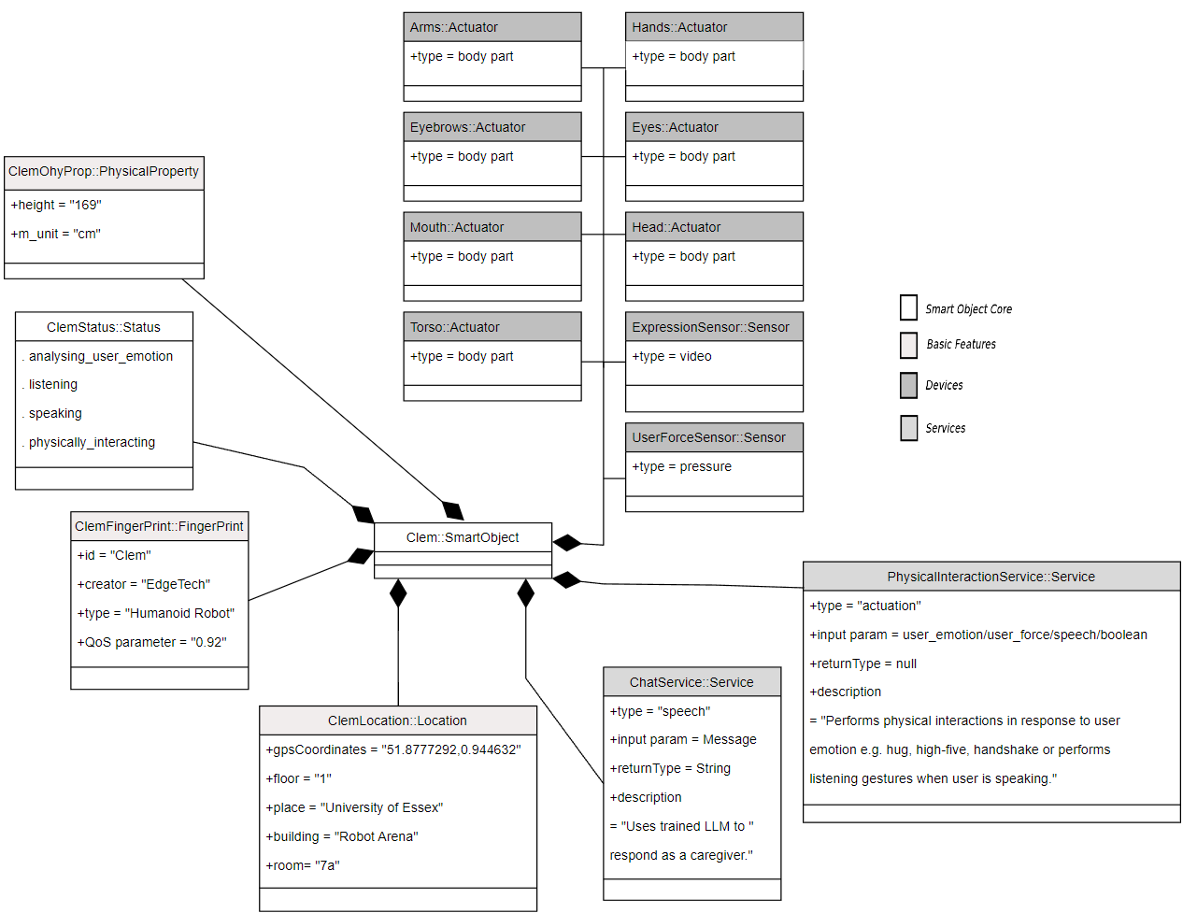

References

Fortino, G., Guerrieri, A., Russo, W. & Savaglio, C. (2015). Towards a Development Methodology for Smart Object-Oriented IoT Systems: A Metamodel Approach. 2015 IEEE International Conference on Systems, Man, and Cybernetics. 1297-1302. DOI: 10.1109/SMC.2015.231.

Glinz, M. (2000). Problems and deficiencies of UML as a requirements specification language. Tenth International Workshop on Software Specification and Design. IWSSD-10. 2000: 11–22. DOI: https://doi.org/10.1109/IWSSD.2000.891122.

Meneghello, F., Calore, M., Zucchetto, D., Polese, M., and Zanella, A. (2019) ‘IoT: Internet of Threats? A Survey of Practical Security Vulnerabilities in Real IoT Devices’, IEEE Internet of Things Journal. 6(5): 8182-8201. DOI: https://doi.org/10.1109/JIOT.2019.2935189

Sharma, A., Bawa, R.K. (2022). Identification and integration of security activities for secure agile development. Int. j. inf. tecnol. 14: 1117–1130. DOI: https://doi.org/10.1007/s41870-020-00446-4.

